SIMATS ENGINEERING
ASSESSMENT TOOL 3

COURSE NAME: Database Management Systems
COURSE CODE: CSA05
NAME:JAISURIYA D D
REGNO:192421167

COURSE OUTCOME COVERED

CO2: Apply the relational model, relational algebra, SQL query structures, and views to solve database querying and data manipulation problems. (BL3, BL6)

Activity Tool : Debugging & Optimisation Task (Low)
Assessment Tool Weightage: 30%

Dr

QUESTIONS Total Marks: 50
Q.No | Question | Bloom's Level | Marks
1 | Identify and fix the error in the given SQL query that uses incorrect JOIN syntax and returns duplicate results. | BL3 – Apply | 5
2 | The following sub-query returns incorrect results due to a missing correlation. Debug and rewrite it correctly. | BL3 – Apply | 5
3 | A given SQL view definition causes errors when queried. Identify the issue and rewrite a correct and optimized view. | BL3 – Apply | 5
4 | Debug the given relational algebra expression that produces incorrect output for a natural join operation. | BL3 – Apply | 5
5 | The SQL query below violates referential integrity. Identify the violation and modify the statements to enforce proper constraints. | BL3 – Apply | 5
6 | Given an inefficient SQL query with nested loops, rewrite it using JOIN to optimize performance. | BL6 – Create | 5
7 | The GROUP BY query below produces wrong aggregation results. Debug the query and explain the error. | BL3 – Apply | 5
8 | Identify and fix the logical error in a given SQL UPDATE statement that unintentionally modifies all rows in the table. | BL3 – Apply | 5
9 | Optimize the given multi-table SQL query by restructuring sub-queries into JOINs and using appropriate indexes. | BL6 – Create | 5
10 | Debug a given relational calculus expression that returns an empty result set due to incorrect quantifier usage. | BL3 – Apply | 5

Code of Conduct:

I JAISURIYA D D(192421167) certify that this submission is my original work and that I have adhered to the guidelines specified for this assessment.
I understand that any violation of academic integrity rules will result in disciplinary action.

Signature of the student:
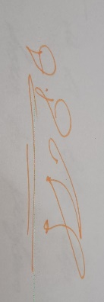
RUBRICS FOR CALCULATION:

Criteria | Weightage | Level 4 (Exemplary) | Level 3 (Proficient) | Level 2 (Developing) | Level 1 (Beginning)
Problem Identification | 20% | Accurately identifies all errors and root causes with clear understanding | Identifies most errors with minor gaps | Identifies some errors but misses key issues | Unable to identify errors correctly
Debugging | 25% | Applies systematic debugging techniques effectively to resolve issues | Uses appropriate debugging methods with minor errors | Limited debugging approach; requires guidance | Unable to debug or resolve issues
Optimization | 20% | Optimizes code by significantly improving time complexity using efficient algorithms | Improves time complexity with minor gaps in efficiency | Limited improvement in time complexity | No improvement; inefficient approach retained
Analysis | 20% | Demonstrates strong logical reasoning and clear justification of solutions | Shows reasonable analysis with some justification | Limited analysis; weak reasoning | No analytical reasoning demonstrated
Code Quality | 15% | Produces clean, well-structured code with proper comments and documentation | Code is mostly clear with minor documentation gaps | Code lacks structure and proper documentation | Poorly written code with no documentation

Q1. Identify and Fix Incorrect JOIN Syntax and Duplicate Results
Question: Identify and fix the error in the given SQL query that uses incorrect JOIN syntax and returns duplicate results.
Answer
The error occurs when tables are joined without a proper JOIN condition. This can produce a Cartesian product, where every row from one table is matched with every row from another table, resulting in duplicate or incorrect records.
Incorrect Query
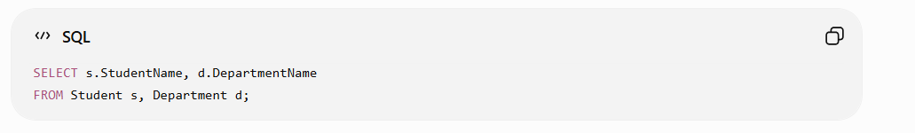
Correct Query
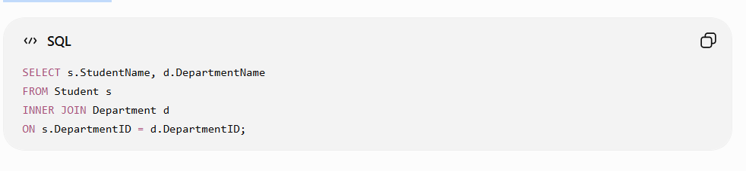
Error Identification
- The original query does not contain a proper JOIN ... ON condition.
- Without the condition, unrelated rows are combined.
- This causes duplicate and incorrect results.

Optimization
Using an explicit INNER JOIN with the appropriate key relationship ensures that only matching records are retrieved. An index on DepartmentID can further improve JOIN performance.
Conclusion
The query is corrected by specifying the relationship between the tables using the ON clause. This eliminates unnecessary duplicate results and produces accurate output.
Rubric coverage:
error identification → debugging → optimization → logical explanation → clean SQL.

Q2. Debug and Rewrite a Correlated Subquery
Question: The following sub-query returns incorrect results due to a missing correlation. Debug and rewrite it correctly.
Answer
A correlated subquery is a subquery that depends on a value from the outer query. The error occurs when the inner query does not correctly reference the outer query.
Incorrect Query
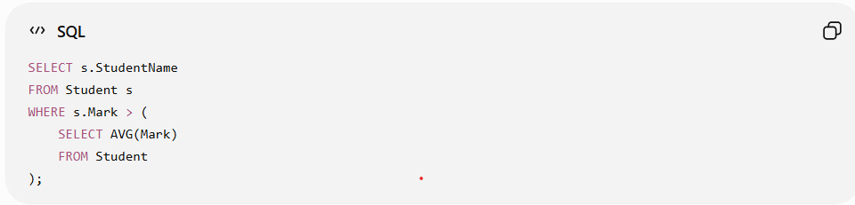
The subquery calculates the average mark of all students, instead of calculating the average for the relevant group.
Correct Query
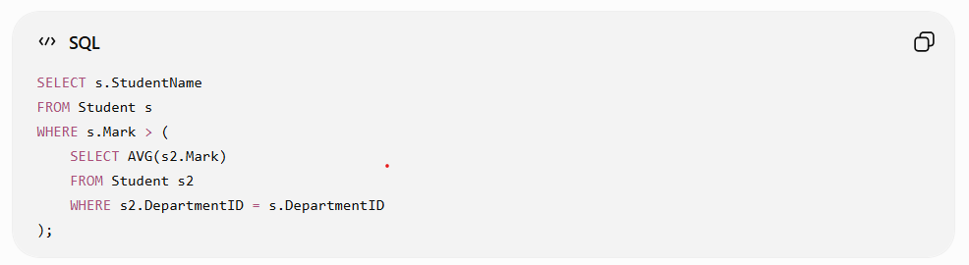
Error Identification
- The original subquery is not correlated with the outer query.
- It calculates one overall average for all students.
- The inner query must reference s.DepartmentID from the outer query.

Debugging
The correlation is added using:
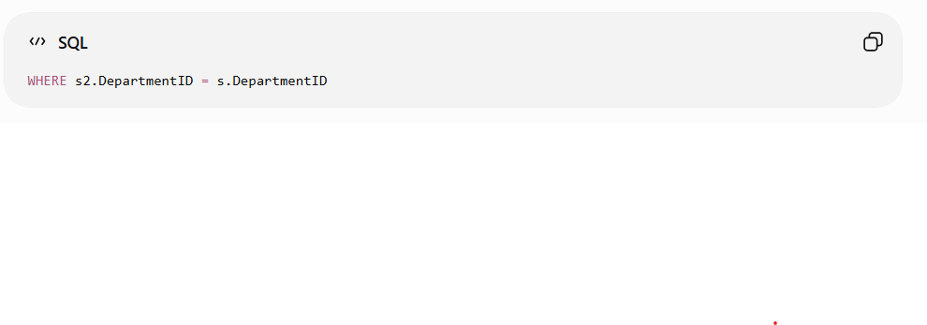

Now, for each student, the subquery calculates the average mark of that student's department.
Conclusion
The corrected correlated subquery produces accurate results because the inner query is linked to the outer query through DepartmentID. This demonstrates proper debugging and logical use of subqueries.
Q3. Debug and Optimize an SQL View
Question: A given SQL view definition causes errors when queried. Identify the issue and rewrite a correct and optimized view.
Answer
An SQL view is a virtual table based on the result of an SQL query. Errors can occur when the view contains incorrect column references, improper JOIN conditions, or unnecessary operations.
Incorrect View
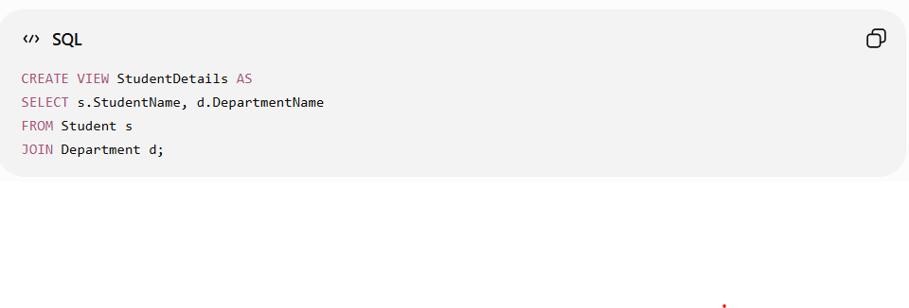
The error is that the JOIN does not contain an ON condition. Therefore, the database cannot determine how the two tables should be related.
Correct and Optimized View
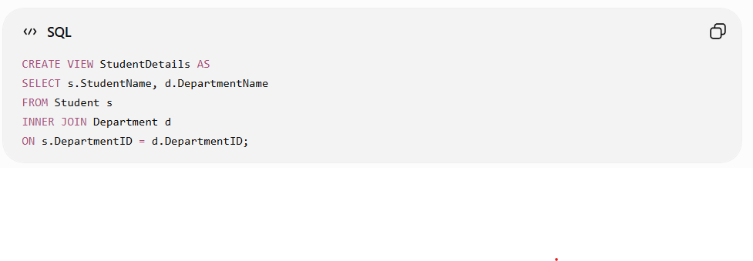
Error Identification
- The original view uses JOIN without an ON condition.
- This causes an invalid or unintended table combination.
- The relationship between Student and Department must be specified.
Optimization
The corrected view:
- Uses an explicit INNER JOIN.
- Retrieves only the required columns.
- Uses the related DepartmentID columns for efficient matching.
- An index on DepartmentID can further improve query performance.
Conclusion
The view is corrected by adding the proper JOIN condition. This makes the view valid, avoids unwanted results, and improves query efficiency.
Q4. Debug Relational Algebra Expression for Natural Join
Question: Debug the given relational algebra expression that produces incorrect output for a natural join operation.
Answer
A natural join (⋈) combines two relations based on their common attribute(s). The common attribute should have the same meaning and compatible values in both relations.
Incorrect Expression
Suppose we have:
- STUDENT(Student_ID, Student_Name, Dept_ID)
- DEPARTMENT(Dept_ID, Dept_Name)
An incorrect expression is:
STUDENT ⋈ STUDENT.Dept_ID = DEPARTMENT.Dept_ID DEPARTMENT
The problem is that this uses an explicit join condition with the natural join operator.
Correct Natural Join
STUDENT ⋈ DEPARTMENT
The common attribute Dept_ID is automatically used for matching.
Error Identification
- Natural join automatically identifies common attributes.
- Providing an explicit condition is unnecessary for a natural join.
- If unrelated common attributes exist, natural join may also produce incorrect results because it joins using all attributes with the same name.
Debugging
The expression should be checked to ensure that:
- Both relations contain the required common attribute.
- The common attribute represents the same data.
- The natural join operator ⋈ is used correctly.
Conclusion
The corrected expression is:
STUDENT ⋈ DEPARTMENT
It produces the required result by matching tuples using the common Dept_ID attribute. This removes the incorrect join condition and gives the intended natural join output.
Q5. Referential Integrity Violation
Question: The SQL query violates referential integrity. Identify the violation and modify the statements to enforce proper constraints.
Answer
Referential integrity ensures that a foreign key value in one table must match an existing primary key value in the referenced table.
Incorrect Statements
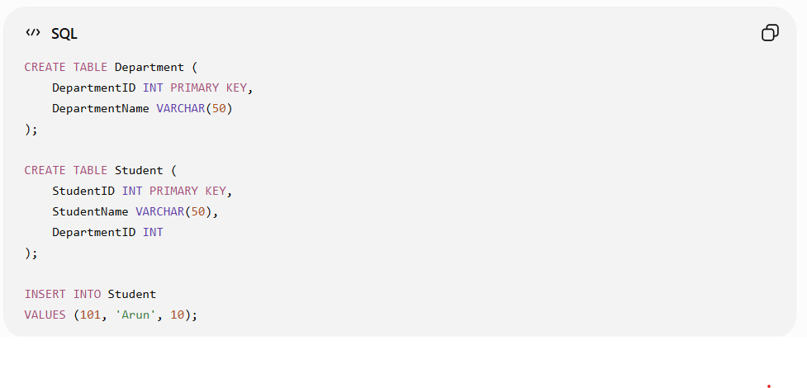
Here, DepartmentID = 10 does not exist in the Department table. Therefore, the relationship between the two tables is not maintained.
Corrected Statements
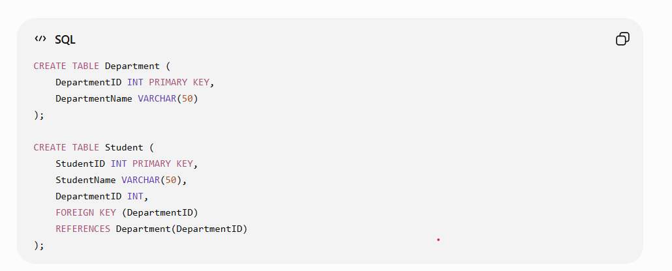
First insert the parent record:
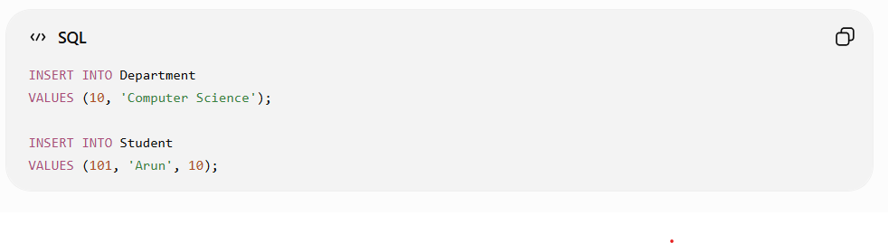
Error Identification
- Student.DepartmentID refers to Department.DepartmentID.
- The value 10 must exist in the parent table before it is inserted into the child table.
- Without a foreign key constraint, invalid department values may be inserted.
Conclusion
Adding a FOREIGN KEY constraint enforces referential integrity and prevents invalid or orphan records from being inserted. This maintains consistency between the related tables.
Q6. Optimize an SQL Query Using JOIN
Question: Given an inefficient SQL query with nested loops, rewrite it using JOIN to optimize performance.
Answer
Nested subqueries can require repeated searches of the same table, making the query inefficient. A JOIN can combine related tables directly and reduce unnecessary processing.

Inefficient Query
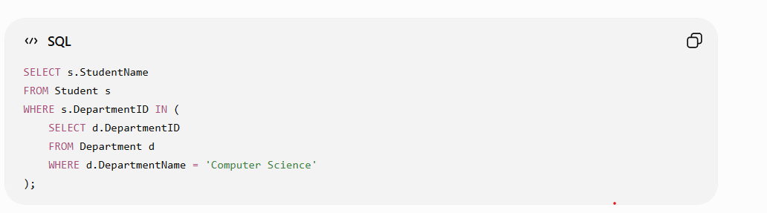
Optimized Query Using JOIN
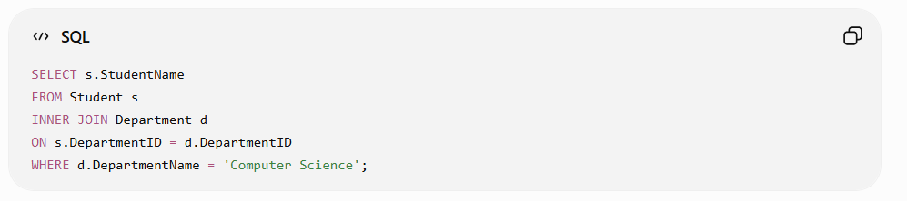
Error / Problem Identification
- The original query uses a nested subquery.
- The database may repeatedly search the Department table.
- This can increase processing time when the tables contain many records.
Optimization
The JOIN directly connects the related tables using DepartmentID.
Advantages:
- Reduces unnecessary nested processing.
- Makes the relationship between tables clear.
- Can improve query execution performance.
- Indexing DepartmentID can further improve JOIN performance.
Conclusion
Replacing the nested subquery with an INNER JOIN provides a clearer and potentially more efficient query. This satisfies the optimization requirement by reducing unnecessary processing and improving query structure.
Q7. Debug GROUP BY Aggregation Query
Question: The GROUP BY query produces wrong aggregation results. Debug the query and explain the error.
Answer
The GROUP BY clause is used to group rows having the same values and apply aggregate functions such as COUNT(), SUM(), and AVG().
Incorrect Query
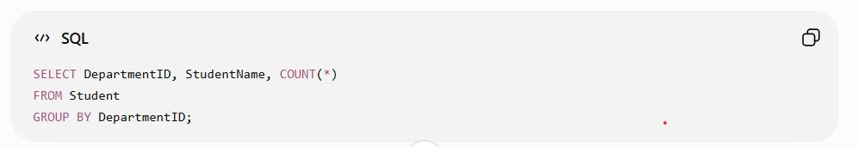
Error
The query selects StudentName, but StudentName is neither:
- included in the GROUP BY clause, nor
- used with an aggregate function.
Therefore, the query can produce an error or incorrect/indeterminate results depending on the SQL mode.
Correct Query
If the requirement is to find the number of students in each department:
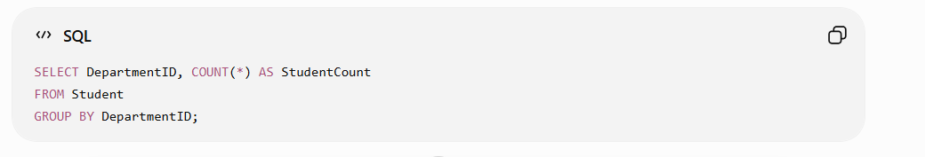
Debugging
- Identify the columns used in SELECT.
- Check whether non-aggregated columns are included in GROUP BY.
- Remove unnecessary columns or add them to GROUP BY.
- Use aggregate functions correctly.
Conclusion
The error is caused by selecting StudentName without grouping it or applying an aggregate function. The corrected query groups students by DepartmentID and counts the students in each department, producing accurate aggregation results.
Q8. Debug SQL UPDATE Statement
Question: Identify and fix the logical error in a given SQL UPDATE statement that unintentionally modifies all rows in the table.

Answer
The UPDATE statement modifies existing records in a table. A WHERE clause is required when only specific rows should be modified.
Incorrect Query
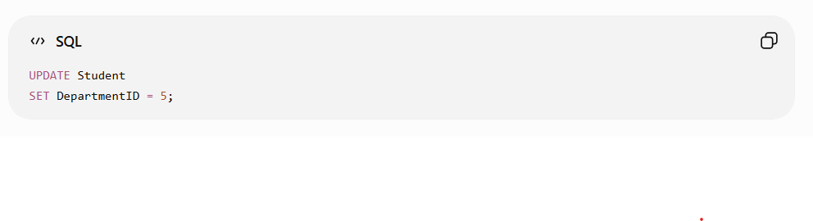
Error Identification
The query does not contain a WHERE clause. Therefore, the DepartmentID of every student in the Student table will be changed to 5.
This is a logical error, because the query executes successfully but produces an unintended result.
Correct Query
For example, to update only student 101:
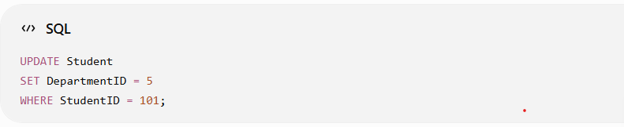
Debugging Steps
- Check the UPDATE statement.
- Identify whether a WHERE condition is present.
- Determine which specific record should be modified.
- Add the appropriate condition to the WHERE clause.
- Verify the affected rows before executing the update.

Conclusion
The error is the absence of a WHERE clause. Adding a suitable WHERE condition ensures that only the intended record is modified and prevents accidental changes to the entire table.

Q9. Optimize a Multi-Table SQL Query
Question: Optimize the given multi-table SQL query by restructuring sub-queries into JOINs and using appropriate indexes.
Answer
A multi-table query can become inefficient when multiple subqueries repeatedly access related tables. Using JOINs allows the database to combine related records more efficiently.
Inefficient Query
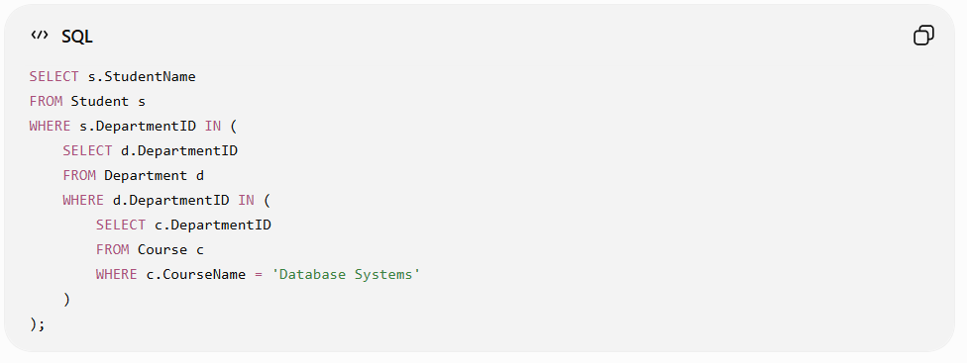
Optimized Query Using JOIN
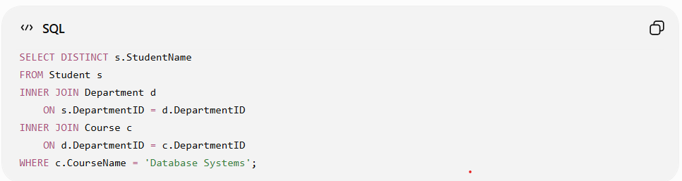
Error / Performance Issue
- The original query uses multiple nested subqueries.
- Related tables are accessed through repeated subquery operations.
- This can increase query processing time for large tables.
Optimization
The query is optimized by:
- Replacing nested subqueries with INNER JOIN.
- Using DISTINCT to avoid duplicate student names.
- Creating indexes on columns used for joining and filtering.
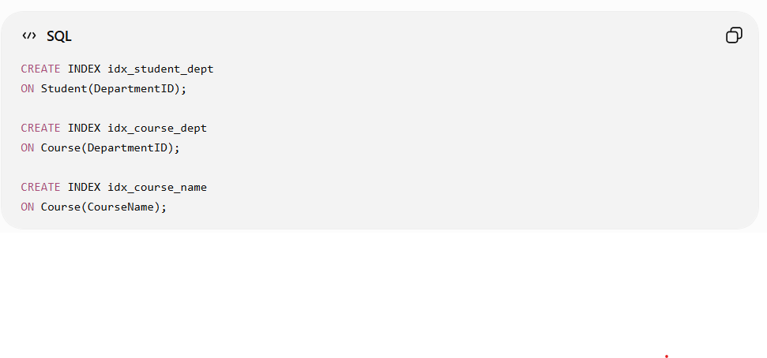
Conclusion
Using JOINs instead of nested subqueries simplifies the query and can improve execution performance. Appropriate indexes on DepartmentID and CourseName further reduce the time required to search and join records.
Q10. Debug Relational Calculus Expression
Question: Debug a given relational calculus expression that returns an empty result set due to incorrect quantifier usage.
Answer
Relational calculus uses quantifiers such as ∃ (there exists) and ∀ (for all) to specify conditions on tuples. Incorrect use of these quantifiers can cause the expression to return an empty result.
Incorrect Expression
Suppose we want to find students who belong to the Computer Science department:
{ s | Student(s) ∧ ∀d (Department(d) → s.Dept_ID = d.Dept_ID) }
Error Identification
The ∀ (for all) quantifier is incorrect here. The condition requires a student to have the same Dept_ID as every department, which is normally impossible. Therefore, the expression returns an empty result.
Correct Expression
Use the ∃ (there exists) quantifier:
{ s | Student(s) ∧
∃d (Department(d) ∧
d.Dept_ID = s.Dept_ID ∧
d.Dept_Name = 'Computer Science') }
Debugging
- ∀ means the condition must be true for every department.
- ∃ means at least one matching department must exist.
- The corrected expression checks whether a department exists with the same Dept_ID as the student.
- It then filters the department to Computer Science.
Conclusion
The empty result was caused by the incorrect use of the universal quantifier ∀. Replacing it with the existential quantifier ∃ correctly identifies students having a matching Computer Science department.

